# **WPF**

## Entity Framework

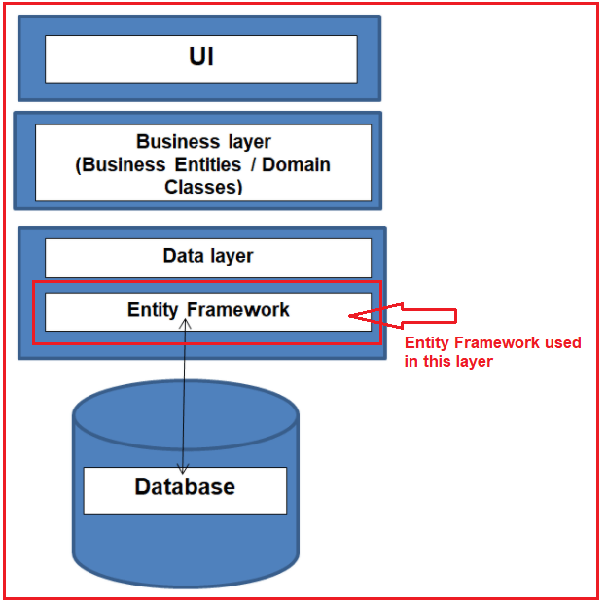 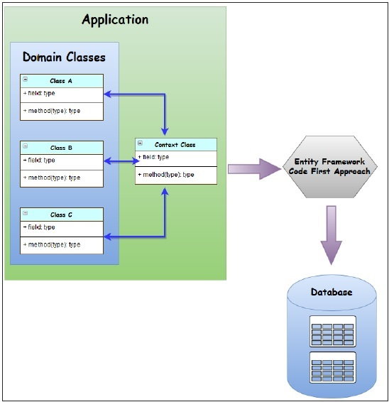

### In Entity Framework Core **Delete Behavior**

1. **DeleteBehavior.Cascade**: This option indicates that when an entity is deleted, the deletion should cascade to related entities. In other words, deleting the principal entity will also delete the dependent entities that have a foreign key relationship with it.
2. **DeleteBehavior.Restrict**: This option indicates that when an entity is deleted, the deletion is restricted if there are related entities. If there are dependent entities associated with the principal entity, the deletion will fail with a referential integrity exception. You would need to manually delete the related entities before deleting the principal entity.
3. **DeleteBehavior.SetNull**: This option indicates that when an entity is deleted, the foreign key property in the related entities will be set to null. This requires the foreign key property to be nullable. If the foreign key property is not nullable, this option is not applicable.
4. **DeleteBehavior.ClientSetNull**: This option is similar to SetNull, but it is intended for scenarios where the foreign key property is not nullable. Instead of setting the foreign key property to null, it throws an exception when an attempt is made to delete the principal entity with dependent entities still referencing it.
5. **DeleteBehavior.NoAction**: This option indicates that no cascading action should be performed when an entity is deleted. It does not modify the related entities in any way and relies on the database constraints to handle the referential integrity.

By default, SQL Server applies ON DELETE NO ACTION

Server name: PG-SUPPORT-22\SQLEXPRESS

Login: sa Password: data#123

Microsoft.EntityFrameworkCore.SqlServer

Microsoft.EntityFrameworkCore.SqlServer.Design

Microsoft.EntityFrameworkCore.Tools

Microsoft.EntityFrameworkCore.SqlServer

optionsBuilder.UseSqlServer(@"Data Source=PG-SUPPORT-22\SQLEXPRESS;Initial Catalog=TestDB;Persist Security Info=True;User ID=sa;Password=data#123; TrustServerCertificate=True");

### Migration

Microsoft.EntityFrameworkCore.Tools

Add-Migration InitialCreate Add-Migration __name migration__

Update-Database

PM **> Add-Migration AddingColumn**

**PM> Update-database**

### Add data

### Display data

### Update

### Delete

### **2-existing-databases**

From existed database to c# as Entity Framework.

**Scaffold-DbContext "Data Source=PG-SUPPORT-22\SQLEXPRESS;Initial Catalog=TestDB;Persist Security Info=True;User ID=sa;Password=data#123; TrustServerCertificate=True;" Microsoft.EntityFrameworkCore.SqlServer -ContextDir Data -OutputDir Models**

Scaffold-DbContext "Data Source=PG-SUPPORT-22\SQLEXPRESS;Initial Catalog=TestDB;Persist Security Info=True;User ID=sa;Password=data#123; TrustServerCertificate=True;" Microsoft.EntityFrameworkCore.SqlServer -ContextDir Data -OutputDir Models **-DataAnnotation**

Using the partial class we are able to modify model entities

Scaffold-DbContext "Data Source=PG-SUPPORT-22\SQLEXPRESS;Initial Catalog=TestDB;Persist Security Info=True;User ID=sa;Password=data#123; TrustServerCertificate=True;" Microsoft.EntityFrameworkCore.SqlServer -ContextDir Data -OutputDir Models/**Generated -ContextNmaspace EntityProgram.Data -Namespace EntityProgram.Models**

## Preprocessor Directives  #if

Preprocessor Directives in C# tell the compiler to process the given information before actual compilation of the program starts.

Depends on the database we choose the inheritance

## Migration_ICOM

optionsBuilder.UseSqlServer("Data Source=PG-SUPPORT-22\\SQLEXPRESS;Initial Catalog=TestDB;Persist Security Info=True;User ID=sa;Password=data#123; TrustServerCertificate=True;");

* + 1. Add-Migration IcomMigrate

1. Update-Database

drop-database

Remove-Migration

From database to EF

## Export import database

Server name: PG-SUPPORT-22\SQLEXPRESS

Login: sa Password: data#123

From SQL Server Management Studio, right-click on the **AdventureWorks2018** database in the **Object Explorer**, then from **Tasks** choose the **Export Data**command:

## Script database

# **ASP.NET MVC**

## Entity Framework 3-web-sites

Microsoft.EntityFrameworkCore

Microsoft.EntityFrameworkCore.SqlServer

Server name: PG-SUPPORT-22\SQLEXPRESS

Login: sa Password: data#123

"DefaultConnection": "Data Source=PG-SUPPORT-22\\SQLEXPRESS;Initial Catalog=RunGroups;Persist Security Info=True;User ID=sa;Password=data#123; TrustServerCertificate=True;"

## Migration

Microsoft.EntityFrameworkCore.Tools



PM**> Add-Migration InitialCreate** Add-Migration __name migration__

PM**> Remove-Migration**

PM**> Add-Migration AddingColumn**

PM> **Update-database**

## Seed (Add data)

dotnet run seeddata

# **Blazor**

## Entity Framework

### Microsoft SQL Local

sqllocaldb create "MyLocal"

Microsoft.EntityFrameworkCore

Microsoft.EntityFrameworkCore.SqlServer

Server name: PG-SUPPORT-22\SQLEXPRESS (localdb)\MyLocal

Login: sa Password: data#123

CRUD_DB BookStories

"LocalConnection": "Data Source=(localdb)\\MyLocal;Initial Catalog=CRUD_DB;User ID=sa;Password=data#123; TrustServerCertificate=True",

### a network-related or instance-specific error occurred

## Migration

Microsoft.EntityFrameworkCore.Tools



PM**> Add-Migration InitialCreate** Add-Migration __name migration__

PM**> Remove-Migration**

PM**> Add-Migration AddingColumn**

PM> **Update-database**

## Seed (Add data)

## OnModelCreating Seed (Add data) **NOT MAIN CODE**

https://www.pragimtech.com/blog/blazor/asp.net-core-rest-api-dbcontext/

This method is called by the framework when your context is first created to build the model and its mappings in memory.

OnModelCreating is called by the framework when it is created the first time to make the models and map into memory. It provides you a way to configure the model class using fluent API. So you make changes in the model class and then add migration and update the database. The generated Snapshot gives you the exact details about the database. It does not get called during the program execution.

# **ASP.NET API**

## 4. Installing Entity Framework

1. create database in mssql
2. install: Microsoft.EntityFrameworkCore Microsoft.EntityFrameworkCore.SqlServer
3. Connect from Visual Studio with MSSql

Server name: PG-SUPPORT-22\SQLEXPRESS (localdb)\MyLocal

Login: sa Password: data#123

CRUD_DB BookStories Films

1. Create ApiDbContext and OnModelCreating

OnModelCreating

https://www.pragimtech.com/blog/blazor/asp.net-core-rest-api-dbcontext/

This method is called by the framework when your context is first created to build the model and its mappings in memory.

OnModelCreating is called by the framework when it is created the first time to make the models and map into memory. It provides you a way to configure the model class using fluent API. So you make changes in the model class and then add migration and update the database. The generated Snapshot gives you the exact details about the database. It does not get called during the program execution.

1. Settings in Program.cs

1. In appsettings.json

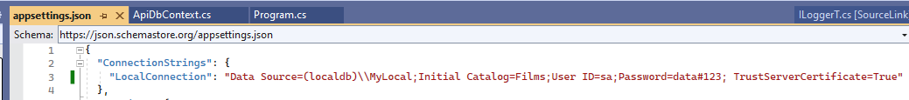

"LocalConnection": "Data Source=(localdb)\\MyLocal;Initial Catalog=Films;User ID=sa;Password=data#123; TrustServerCertificate=True",

1. Migration Microsoft.EntityFrameworkCore.Tools

PM**> Add-Migration InitialCreate** Add-Migration __name migration__

PM**> Remove-Migration**

PM**> Add-Migration AddingColumn**

PM> **Update-database**

1. Seeddata

// create instance for each component

//builder.Services.AddTransient<IAuthorService, AuthorService>();

// create single instance for all components

//builder.Services.AddSingleton<IAuthorService, AuthorService_Version2>();

// create single instance for all components, but it is updated when refresh the page

//builder.Services.AddScoped<IAuthorService, AuthorService>();

1. Settings in Program.cs

or **dotnet run seeddata**

